Revision & Date : RC30103

ReelClean500TM

Optical Fiber Connector Cleaner

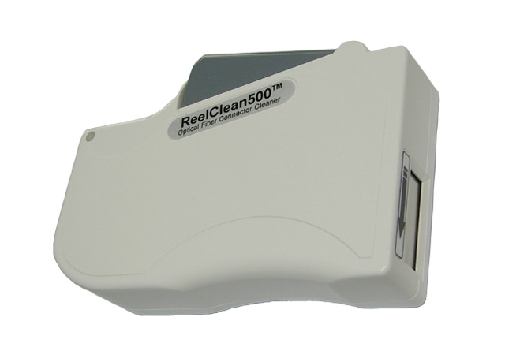
Special Features
• Over 500 wipes by one ReelClean500
• Designed for most kinds of optical connectors
• Compact size for Hand-held operating
• Best Cleaning Effect by one time wipe
• Cleaning Time Save
• Dry Special Anti-Static Microfiber Fabric without
any residues and Lint and Solvent Free
• Easy Replacement Reel
• For cleaning of dust/oil/particle/alcohol/etc
• Windows for showing the remain cleaning times
• By resilient Rubber Pad
• RoHS complied

Specifications

Brand Name ReelClean500
No. of cleaning times by one ReelClean500 over 500 wipes
Housing Material Plastic (White Color)
Applying Connector SC/FC/ST/E2000/LC/MU/D4/MTRJ/LX.5/SMA/etc, PC/APC
Cleaning Fabric Dry Special Anti-Static Microfiber Fabric¹
Dimension and Weight 80(w)x120(l)x25(d)mm, 90g
Packing Individual
Replacement Reel over 500 wipes
¹ Our cleaning fabric was manufactured in Class 100 Cleanroom of global leader of Microfiber market and
guaranteed no risk of scratches & residues on ferrules after cleaning.

How To Clean :
1. Pull the Gray Handle and then automatically open the cleaning slot.
2. Wipe (light-pressed) connector ferrule in the direction of arrow.
3. Take the Handle off.

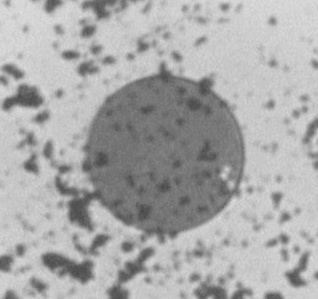
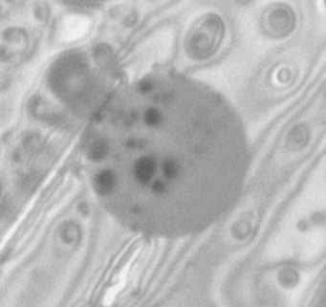
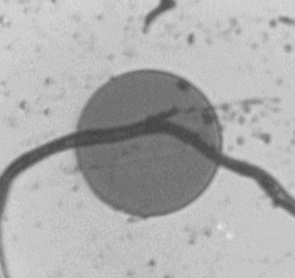
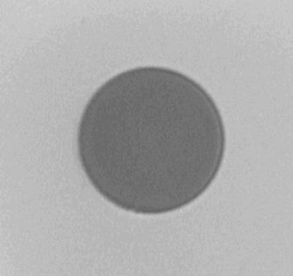

Dust Fingerprint Dirt After Cleaning

Ordering Information :
ReelClean500 : Optical Fiber Connector Cleaner
Replacement Reel : For 500 wipes

TheFibers
C R E AT I V E F I B E R S
Manufacturer : TheFibers Inc.
A-1109 Keumkang Penterium IT Tower, 282 Hagui-ro, Anyang-City, Korea
Tel: +82-31-381-6108 Fax: +82-31-381-6109 sales@thefibers.com

