Revision & Date : HUX30103

HUXCleanerTM

In-Adaptor Ferrule Cleaner
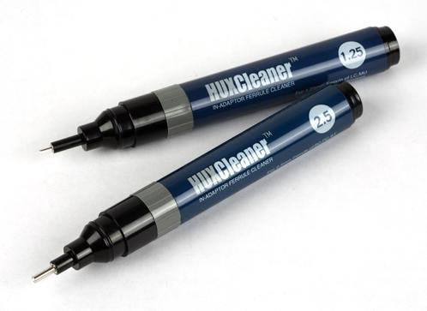
Special Features
• Pen Type : First in the World (Patented)
• Very usefully device to clean Fiber Optic Ferrule
inside of Adaptor in field
• Over 500 wipes by one HUXCleaner
• Best Cleaning Effect
• Cleaning Cost Save
• No need open the Frame to clean the Ferrule
inside of Adaptor
• Used advanced cleaning fabric which has better
suction oil and dust than present swabs
• Easy and Simple and Pocket Portable
• Windows for showing the remain cleaning times
• Any customer size ferrule/stub available
like Transceiver, LEMO, E2000…..

Specifications

Brand Name HUXCleaner
No. of cleaning times by one HUXCleaner over 500 wipes
Housing Material Plastic
Tip Material Plastic/basic¹ or Metal/option
Cleaning Fabric Special Yarn
Length (included Cap) 145mm
Packing Individual
Refill None
¹ The plastic Tip version is basic type to ship unless the customer ask metal Tip optionally.

How To Clean :
1. Insert HUXCleaner Tip into Adaptor and push the Ferrule.
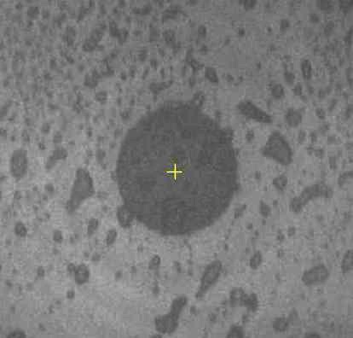
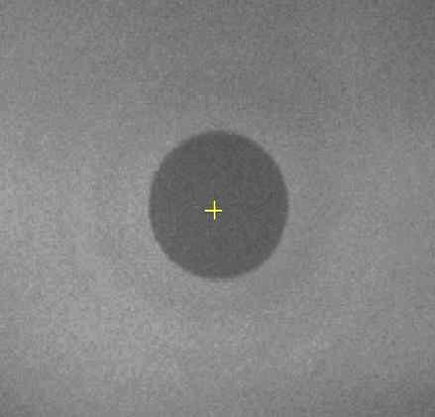
2. Turn Rotator 1~2 clicks clockwise.

Ordering Information :
HUXCleaner-2.5 : For SC, FC, ST with Plastic Tip
HUXCleaner-1.25 : For LC, MU with Plastic Tip
HUXCleaner-2.5E : For SC, FC, ST, E2000 Type
HUXCleaner-2.0 : For 2.0mm LEMO Type [ Before ] [ After ]
HUXCleaner-1.5 : For 1.5mm Military use
HUXCleaner-3.2 : For 3.2mm SMA Type
[Note: We can make the Tip for any customer size Ferrule/Stub.]

TheFibers
C R E AT I V E F I B E R S
Manufacturer : TheFibers Inc.
A-1109 Keumkang Penterium IT Tower, 282 Hagui-ro, Anyang-City, Korea
Tel: +82-31-381-6108 Fax: +82-31-381-6109 sales@thefibers.com

